REPORT ON SERVICOM CDS SENSITIZATION

Event Details

Title: Sensitization Session for NYSC SERVICOM CDS, Osogbo L.G. by FCCPC Osun State Office.

CDS Group: Servicom

Local Govt.: Osogbo Local Government

Date: Tuesday, 16th of September, 2025

Time: 11:00 AM

Venue: FCCPC Osun State Office

Objective
To strengthen collaboration between FCCPC and NYSC Servicom CDS group, foster corps members’ awareness of consumer protection laws, and sensitize participants on FCCPC’s mandate in ensuring consumer rights and fair market practices.

Activity
- Opening prayer and self-introductions
- Introduction of FCCPC staff
- Brief presentation on FCCPC history and mandate
- Paper presentations of
Consumer & Business Education
Quality Assurance & Development, and
Surveillance & Investigation Departments
- Question-and-answer session
- Presentation of gift by Servicom CDS group
- Vote of thanks and closing prayer

Target Group
NYSC Servicom CDS corps members, FCCPC Osun State staff, and invited stakeholders.

Sustainability
The partnership fosters continuous sensitization on consumer rights, encourages corps members to become ambassadors of consumer protection, and sustains collaboration between NYSC and FCCPC for future programs.

PHOTO CREDITS

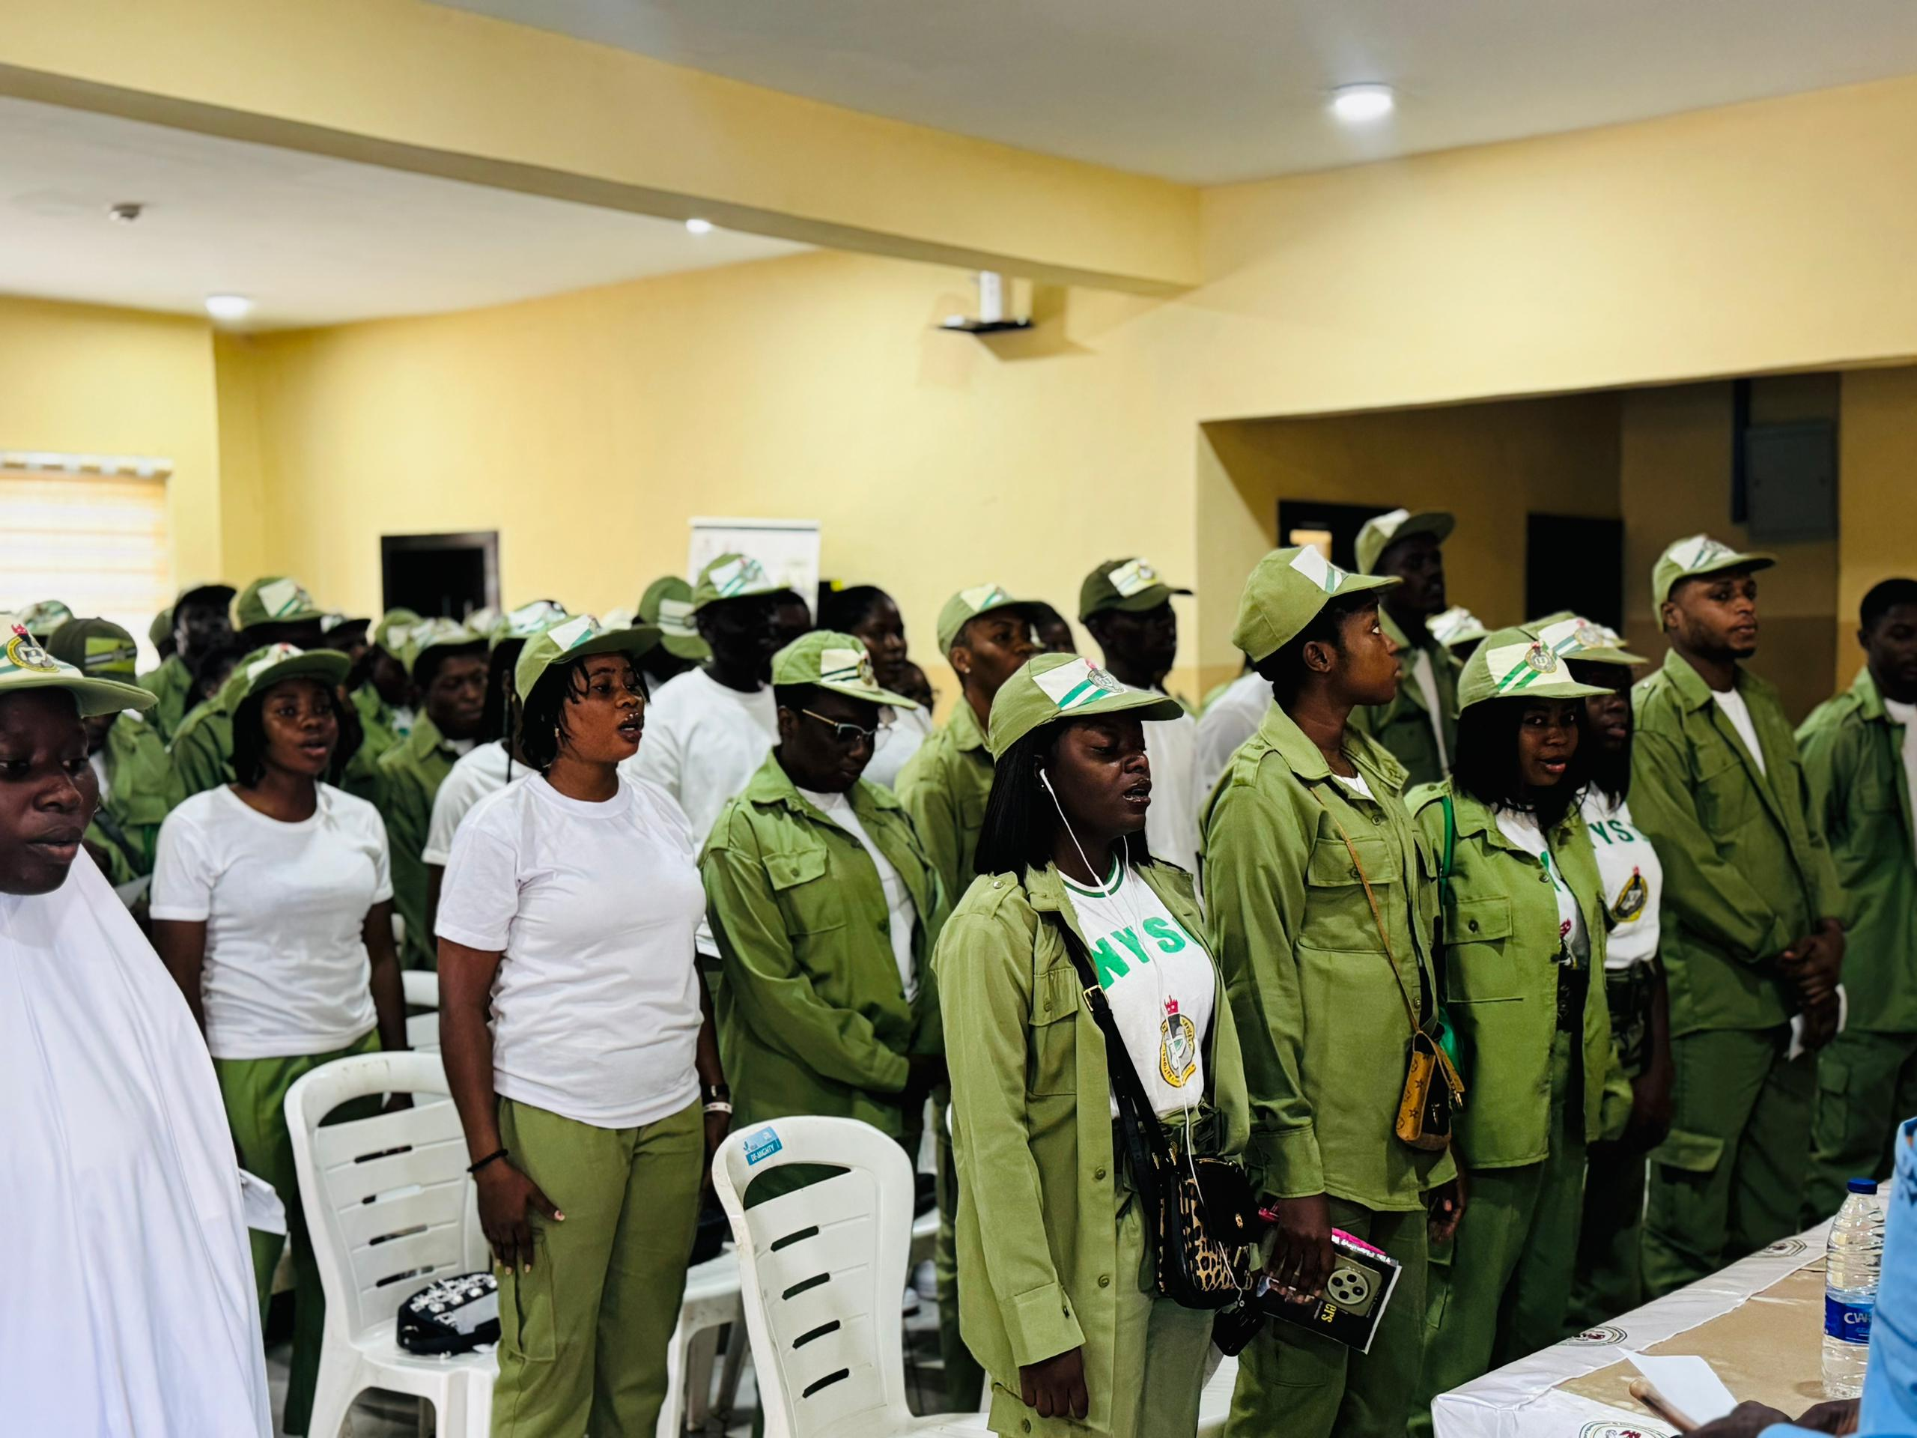

SERVICOM CDS Members Taking the NYSC
Anthem and National Prayer at the beginning
of the Session.

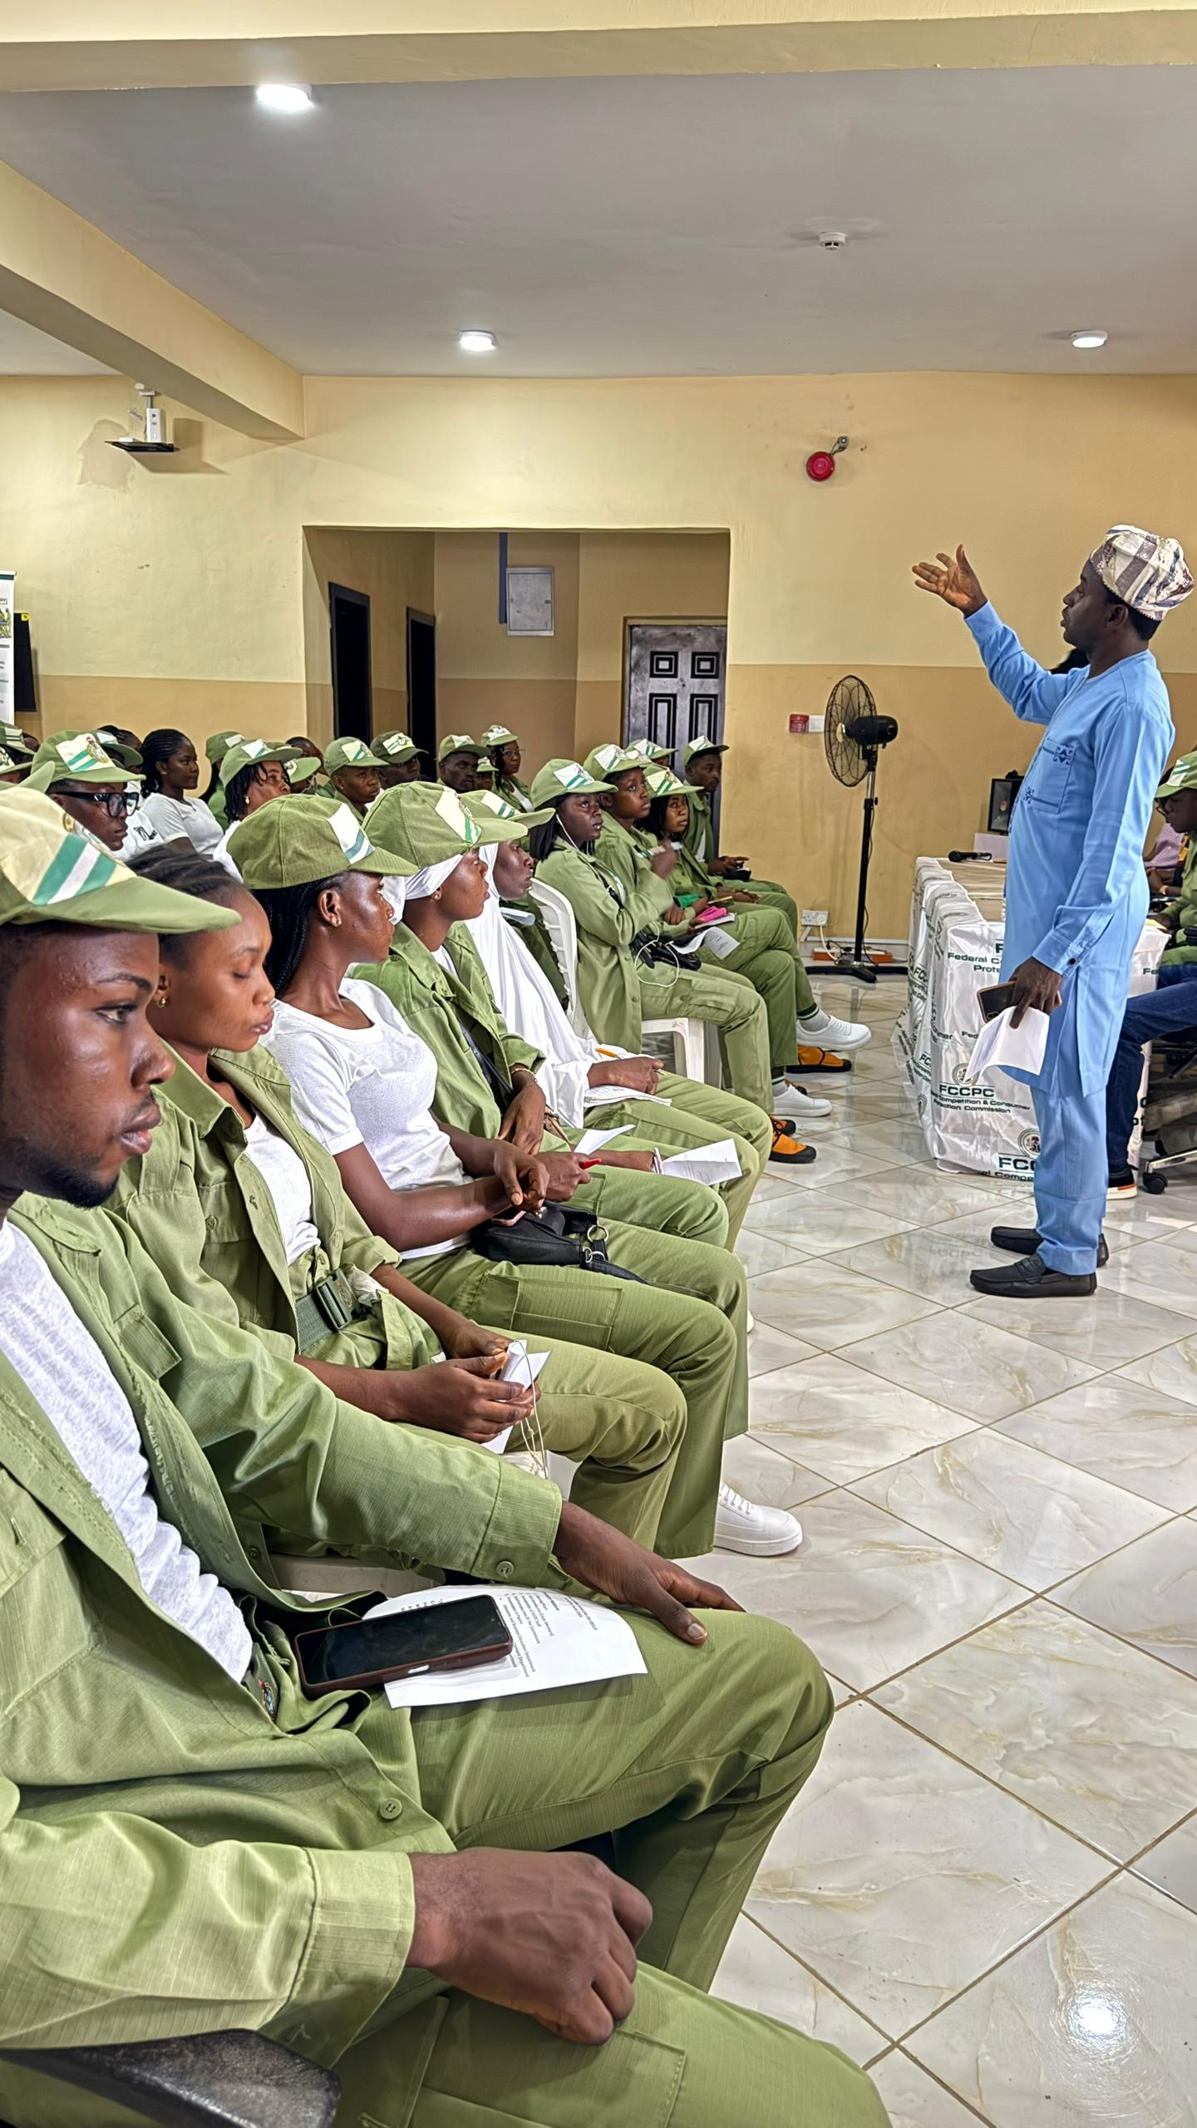

Servicom Cds Members Listening attentively during the session.

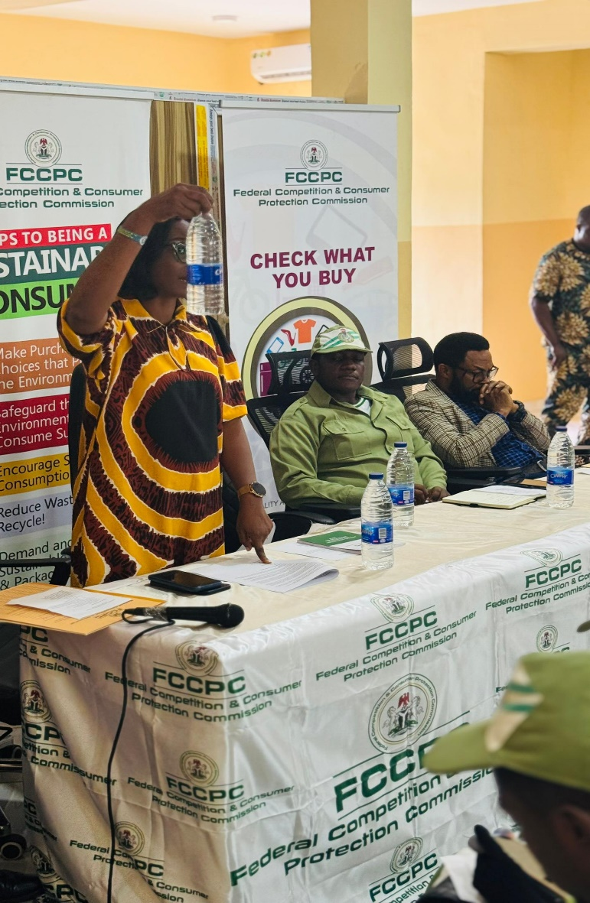

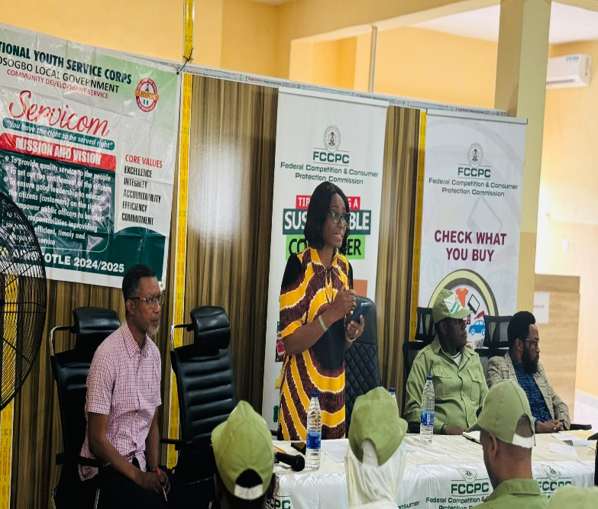

Paper presentation of Consumer & Business Education by Head, Business and Consumer Department, Mrs. Blessing Rufai.

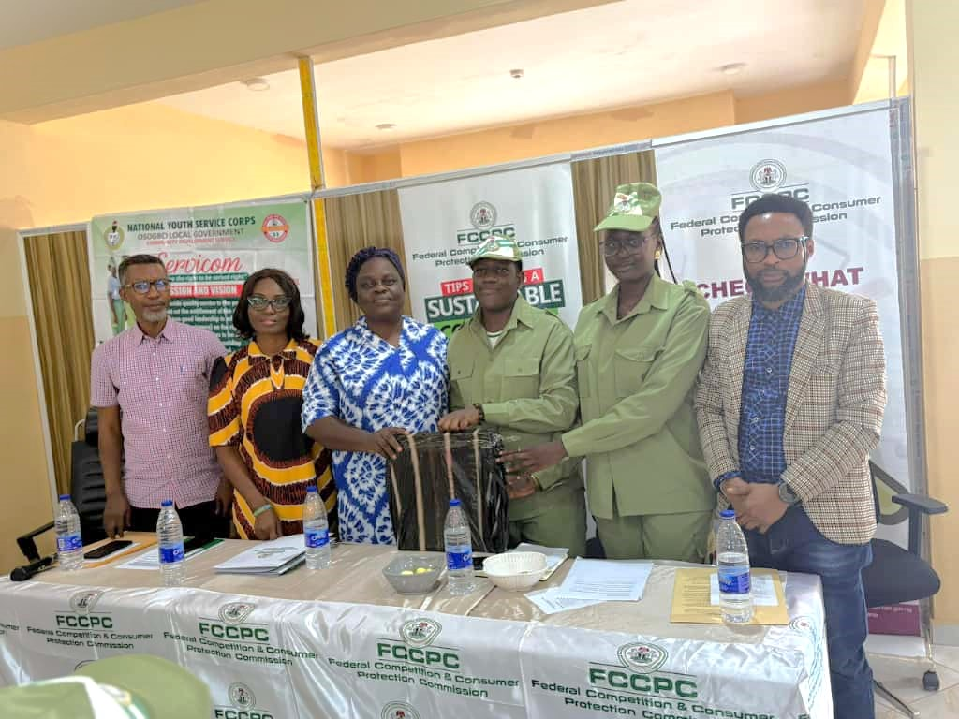

Token of Appreciation presented to the Management, FCCPC Osun State by SERVICOM CDS.
From the Right, Mr. Ndubusi Stanley (Head, Quality Assurance and Developmnt, FCCPC Osun) – Adeyanju Oluwakorede (VP, Servicom CDS) – Malik Mohammed M.O (President, Servicom CDS) – Mrs. Solomon Oluwaloni (State Coordinator, FCCPC Osun State) – Mrs. Blessing Rufai (Head, Business and Consumer Department, FCCPC Osun) – Mr. Ajay (Head, Surveillance and Investigation FCCPC Osun)

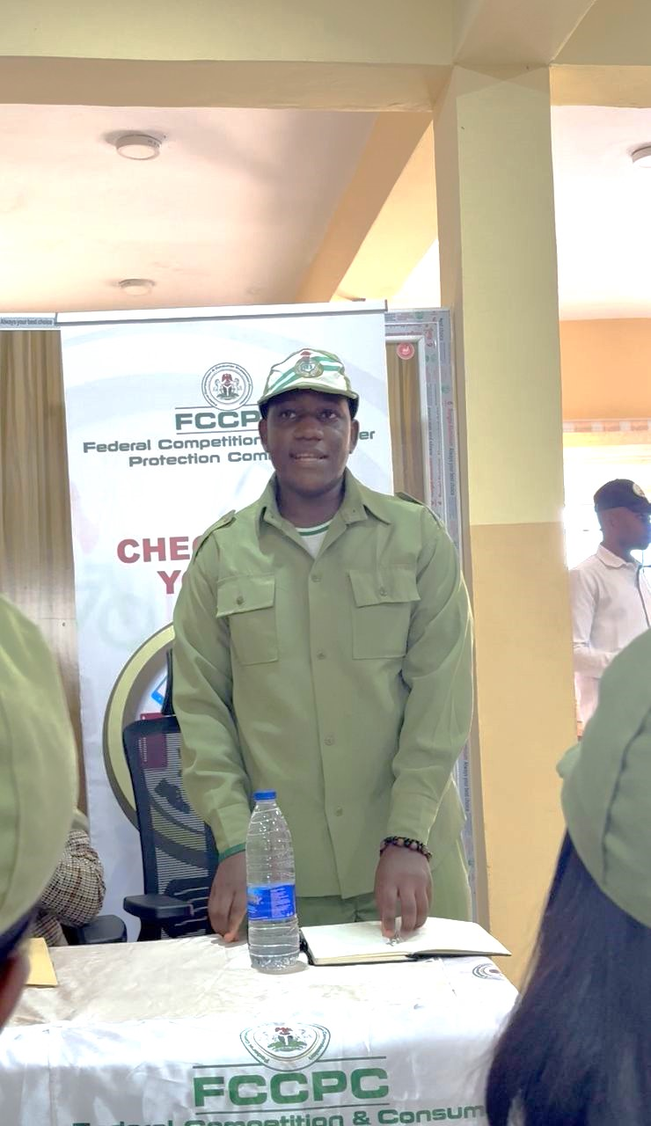

Servicom CDS President Malik Mohammed M.O giving the Vote of Thanks on behalf of Servicom CDS Members

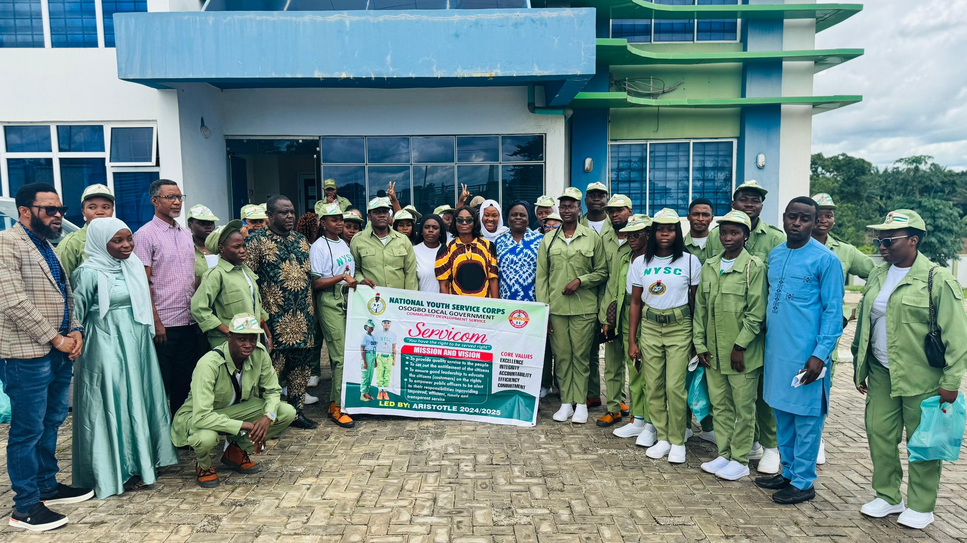

Group Picture of Batch ‘A’ SERVICOM CDS Members with
FCCPC Team Osun State.

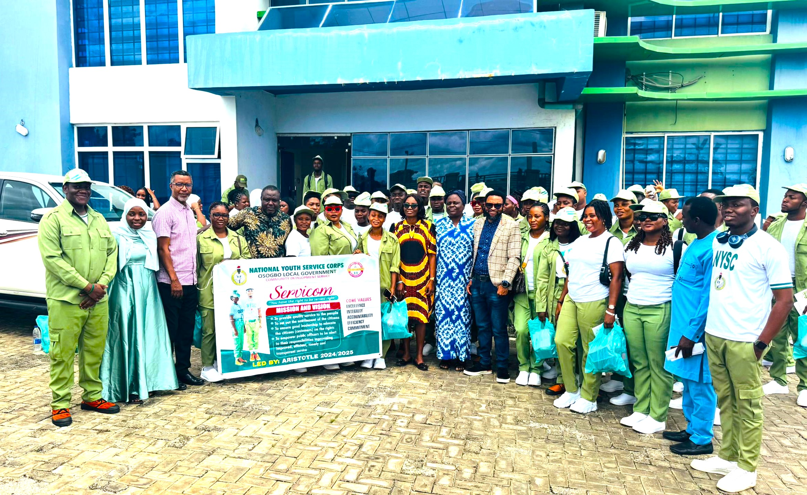

Group Picture of Batch ‘B’ and ‘C’ SERVICOM CDS Members with FCCPC Team Osun State

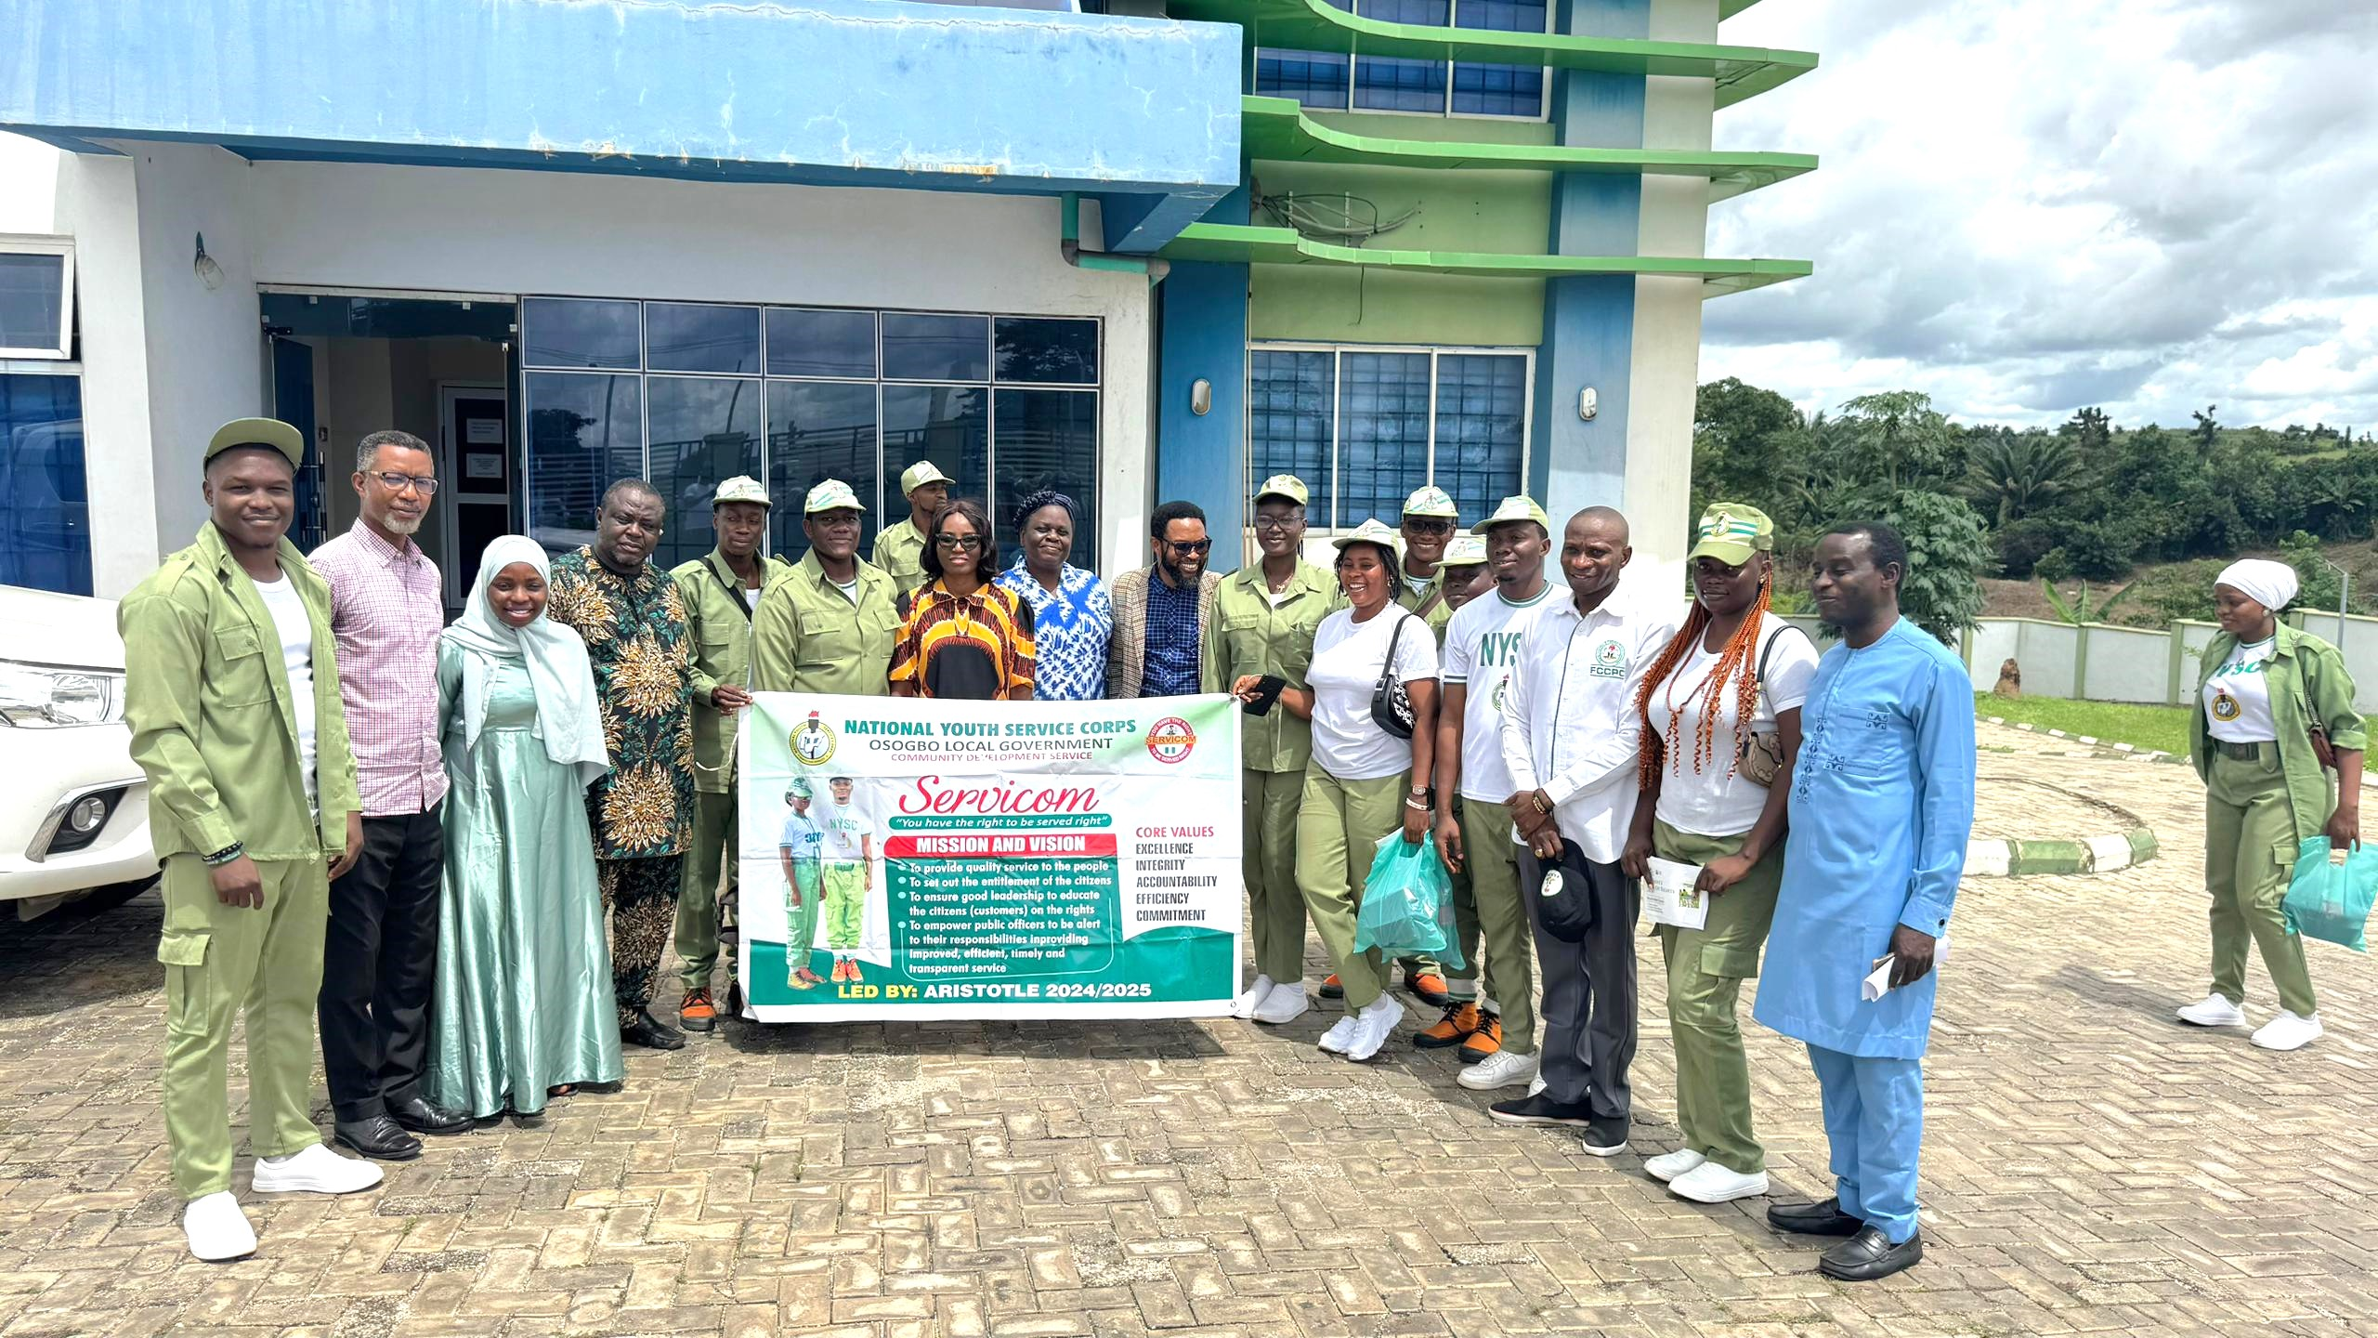

Group Picture of SERVICOM CDS Executives with FCCPC Osun State

